MAHARAJA SURAJMAL INSTITUTE
Affiliated to GGSIP University & NAAC ‘A’ grade accredited


DEPARTMENT OF COMPUTER APPLICATION

Operating System & Linux Programming PRACTICAL FILE
SUBJECT CODE – BCA 301

Submitted by : Lakshay Sakkarwal Submitted to :- Dr. Pooja Singh Enrollment no : 05014902023 Assistant Professor , MSI
Sem : 5th Sec : B (1st shift) Sign :

Practical 6
To understand process related commands like: -ps, top, pstree, nice, renice in Linux.
- ps: This command displays information about active processes running on the system. It shows the process ID (PID), the user running the process, and other details. By default, it shows processes for the current user.
- top: This command provides a real-time view of the system’s running processes and their resource usage (CPU, memory, etc.). It updates continuously, making it useful for monitoring system performance.
- pstree: This command shows processes in a hierarchical tree structure, displaying parent-child relationships between processes. It helps visualize how processes are related.
- nice: This command is used to start a process with a modified scheduling priority. A higher priority means more CPU time, while a lower priority means the process gets less CPU time.
- renice: This command is used to change the priority of a running process. It allows you to adjust the CPU priority of processes that are already executing.
These commands are helpful for managing, monitoring, and adjusting processes and their resource usage on a Linux system.

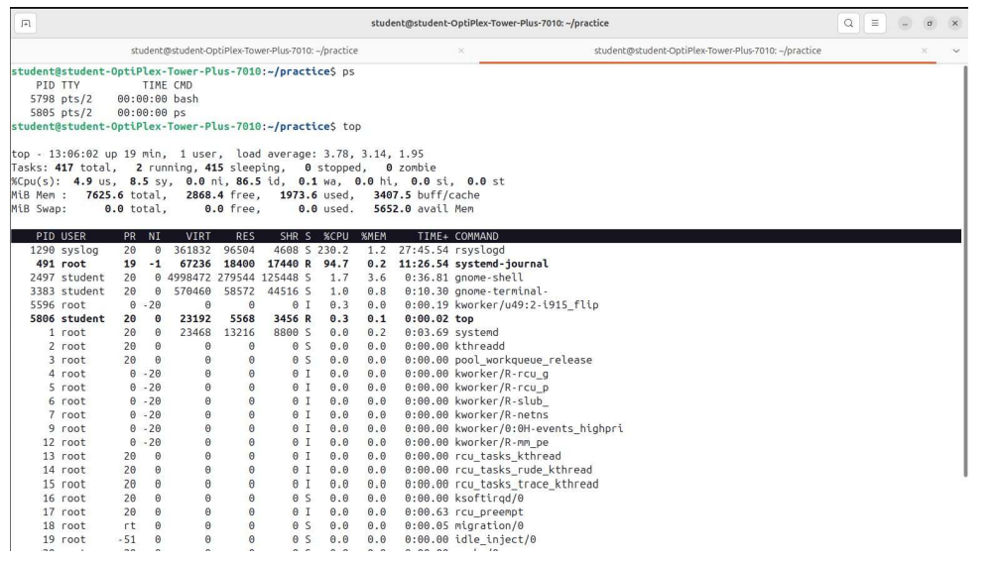

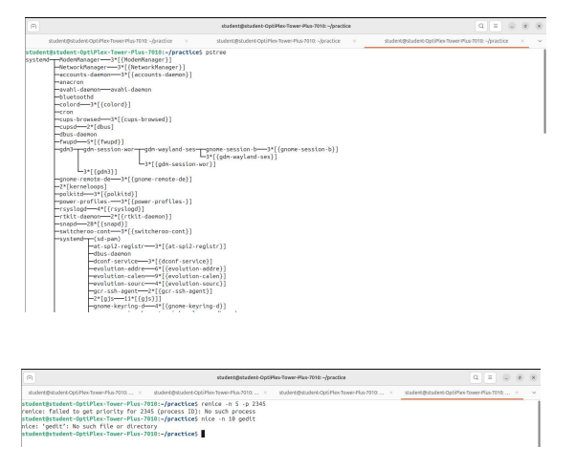

Practical 7

To understand how to examine and change File permissions.

Examine and Change File Permissions
  - Examine File Permissions with ls -l:
The ls -l command lists files with details including permissions. Example output:
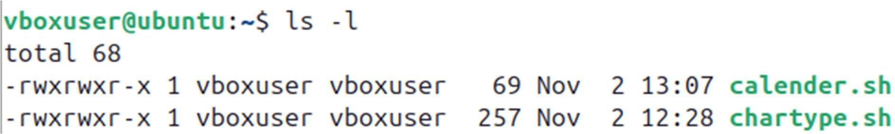
  - The first character represents the file type: - for regular files, d for directories, l for symbolic links.
  - The next nine characters represent permissions:
    - First three characters: owner's permissions (rwx means read, write, execute).
    - Next three characters: group's permissions.
    - Last three characters: others' permissions.

Permissions Explanation:
  - r (read)
  - w (write)
  - x (execute)

Change File Permissions with chmod:
  - To make a file read-only for everyone:
  - This sets the file to be readable by everyone but not writable or executable.
  - You can use symbolic representation as well:

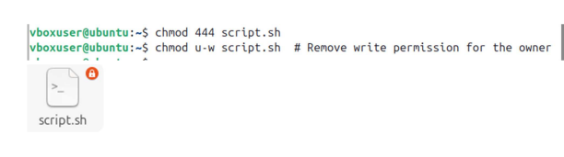

Practical 8

Set a file to be read-only with the chmod command.
Interpret the file permissions displayed by the ls -l command.

Interpret File Permissions with ls -l
Let's break down an example ls -l output:
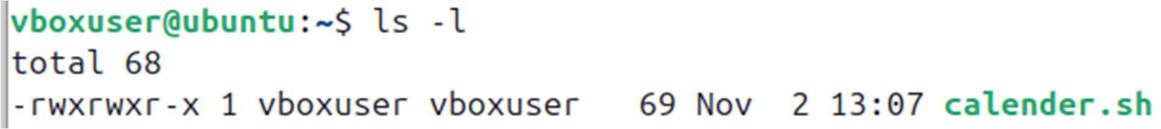
  - - = Regular file
  - rw- = Owner (user) has read and write permissions
  - r-- = Group (group) has read-only permissions
  - r-- = Others have read-only permissions
  - 1 = Number of hard links
  - vboxuser = Owner of the file
  - vboxuser = Group of the file
  - 69 = File size in bytes
  - Nov 2 13:07 = Date and time of last modification
  - Calender.sh = File nam

Practical 9

Delete one or more directories with the rmdir command. See what happens if the directory is not empty.
Experiment (carefully!) with the rm -r command to delete a directory and its content.

Delete One or More Directories with rmdir
The rmdir command deletes empty directories. If you try to delete a non-empty directory, it will fail.
If the directory is not empty, you will get an error:

Delete a Directory and Its Contents with rm -r
Use the rm -r command to recursively delete a directory and all of its contents (files and subdirectories). Be careful with this command as it will permanently delete data.
This will delete mydir and everything inside it. If you want to avoid confirmation prompts, you can use -f (force) flag:
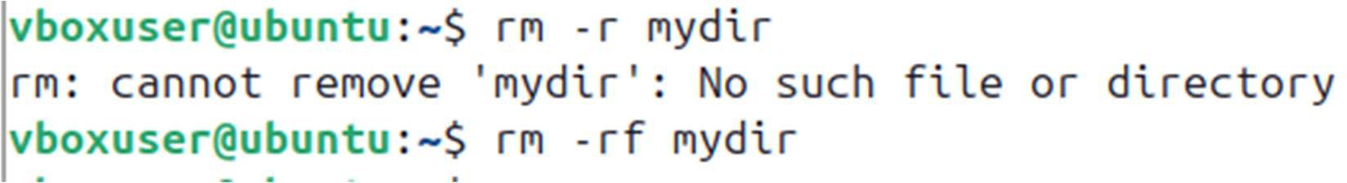

Practical 10

Change your directory to the directory exercises. Create a file in that directory, named the file as example1 using the cat command containing the following text:

water, water everywhere and all the boards did shrink;

water, water everywhere, no drop to drink.
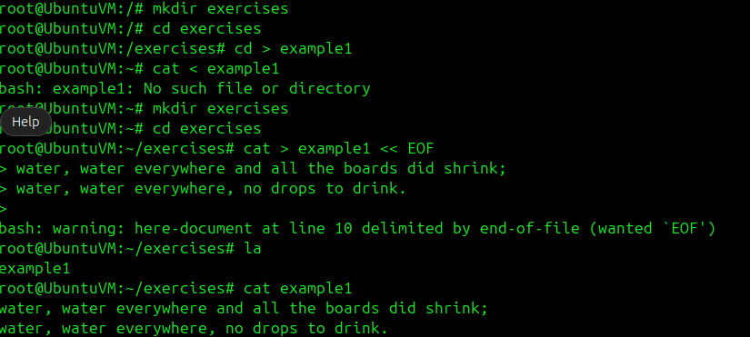

Practical 11

Write basic shell script to display the table of a number.
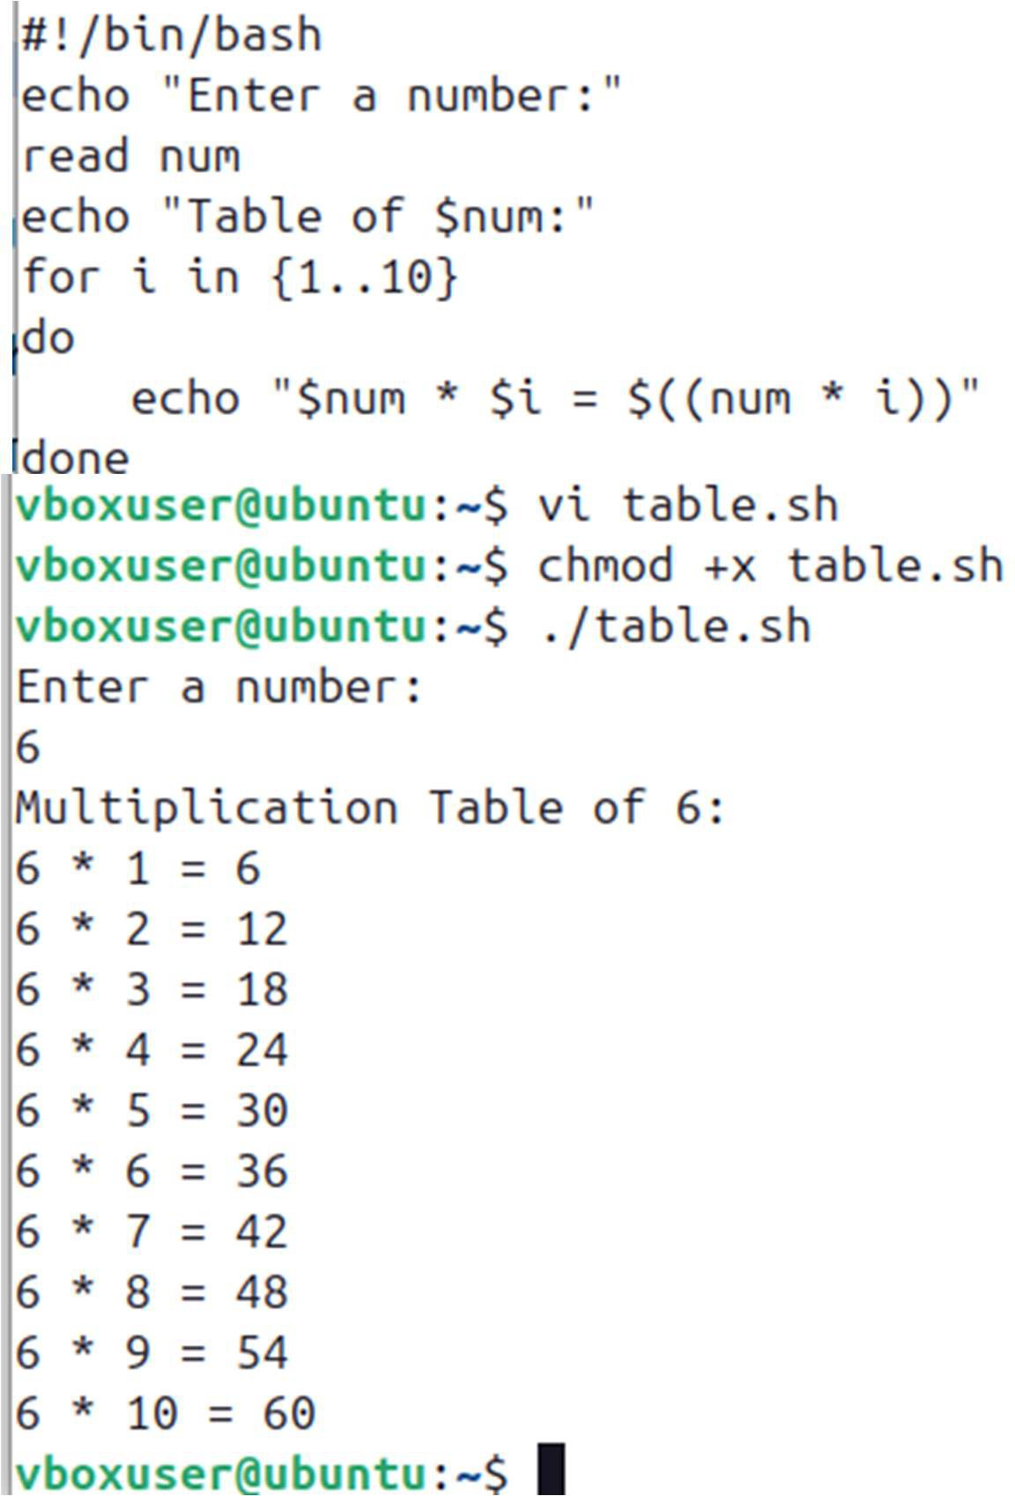

Practical 12

Write basic shell script to input a character from user and then check whether it is uppercase, lowercase or digit.
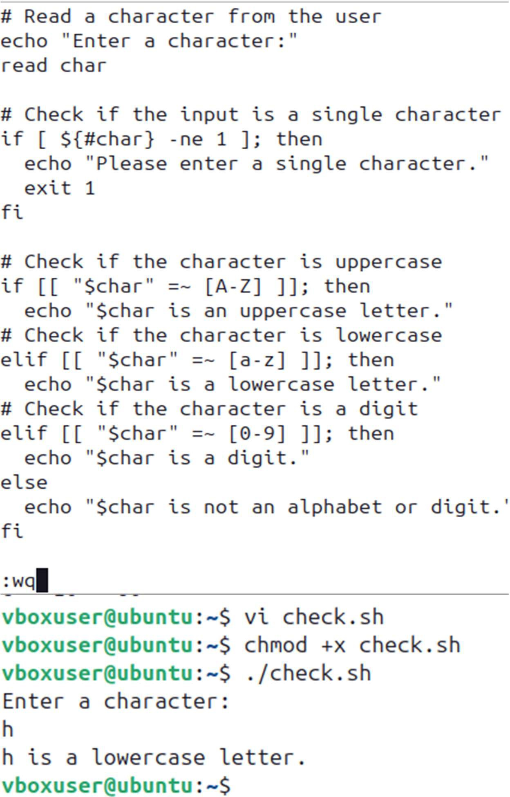

Practical 13

Write basic shell script to calculate factorial of a number.

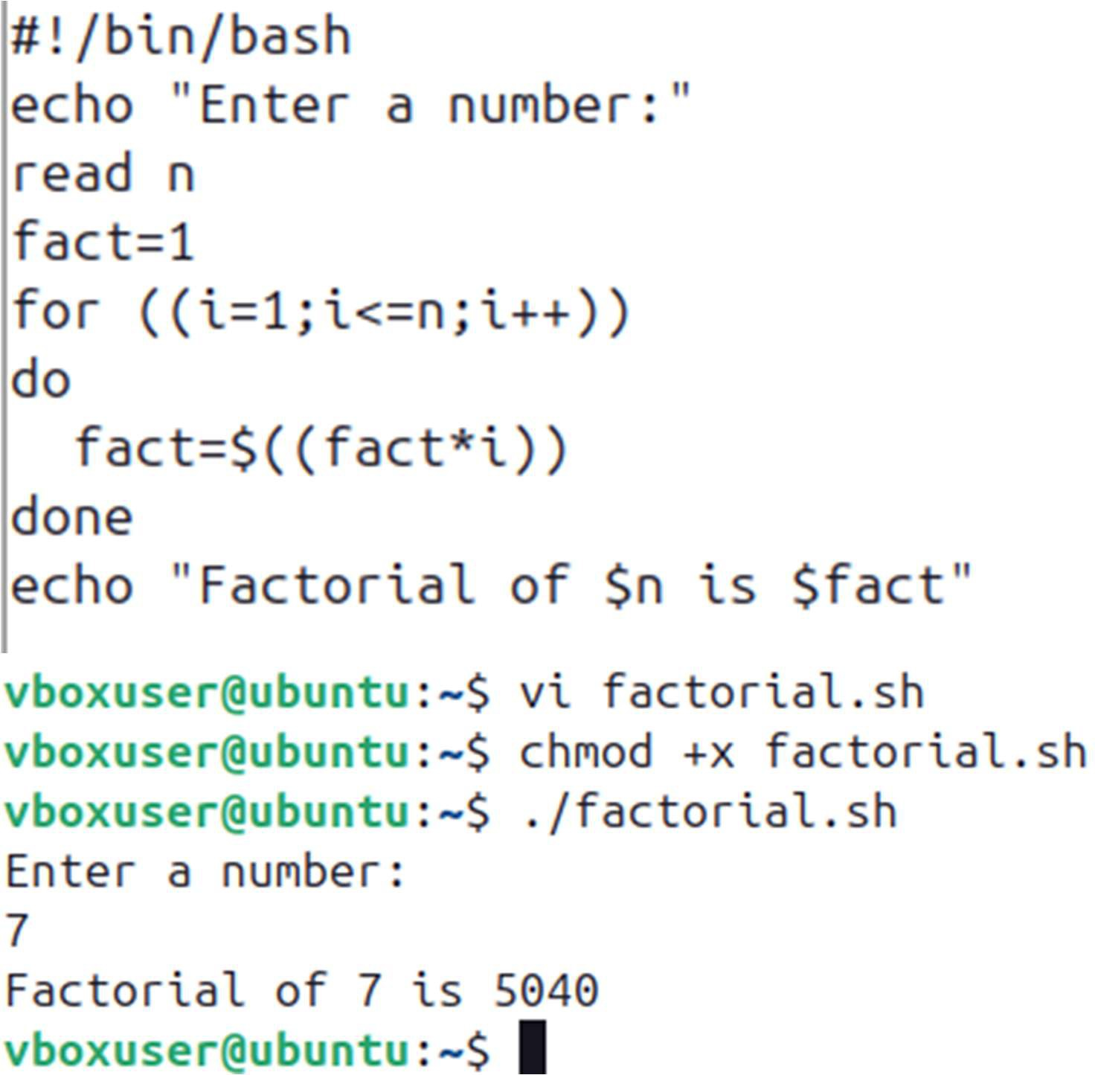

Practical 14

Write basic shell script to input the month number and generate corresponding calendar.
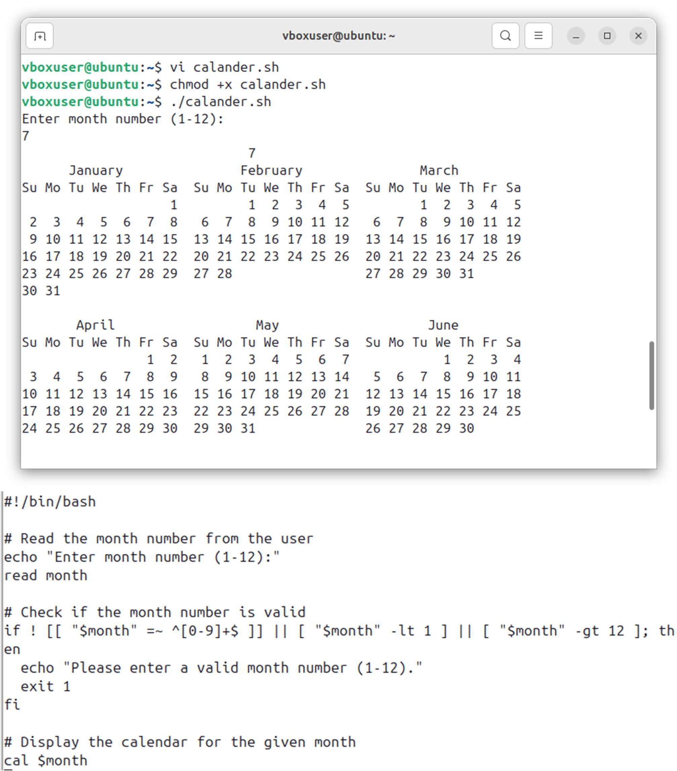

Practical 15
Write basic shell script to list all directories.
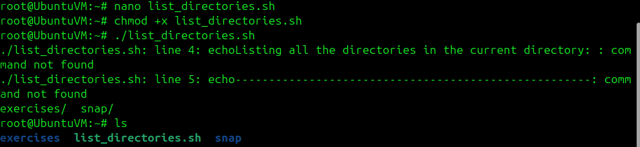
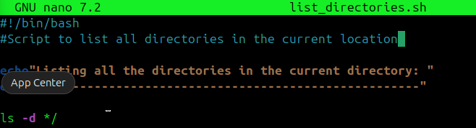
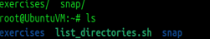

Practical 16
Write basic shell script to display greatest of three numbers.

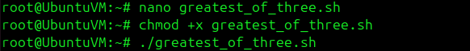
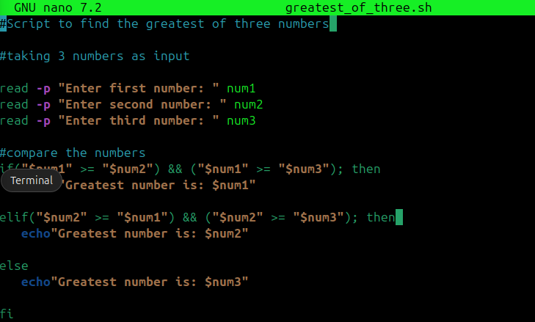
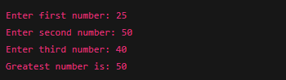

Practical 17
Write basic shell script to check whether the number entered by user is prime or not.
